(v. 2) Module 4.c - Compare two keyword
Start of Block: INFO ABOUT YOU & EXERCISE

IS THIS A TRIAL?
Before you begin, please check the choice below if this is just a trial or experimental exercise that should be ignored in collecting outputs from this module.
☐ Check this field if this is just a trial.

OPEN RESEARCH POLICY STATEMENT
The modules of the WE1S Interpretation Protocol create records of research that support the project's aim of advancing "open, generalizable, and replicable digital humanities methodology" (see project "About" statement). This aim is related to current practices of "open science" and "open-notebook science." The basic idea is that the materials, methods, steps, and findings of research should be transparent so that other researchers know how conclusions were reached and can test or reproduce the process--an ideal that is especially needed for understanding such machine-learning methods as topic modeling (see WE1S bibliography on machine-learning interpretability).

In completing this and other modules of the WE1S Interpretation Protocol you are creating an "open notebook" that in principle can be shared with others as a public record of research. Please be sure that all descriptions, observations, and notes you write in this module are consistent with being part of public record--that is, appropriate in tone, respectful to others, and not in violation of privacy or copyright restrictions.

However please also do not let the ideal of open-notebook science inhibit you from speculative or tentative in-progress commentary. It is understood that research, open or otherwise, is a process of finding knowledge with many stages and levels of confidence. (At the conclusion of this and other modules of the Interpretation Protocol, you will be asked to rate your confidence level in the current exercise.)

In addition, lab notebooks are allowed to be messy as a part of the research process. It is not expected that notes written into these modules be copyedited as if for formal publication. (The time for polishing is later when writing up a report synthesizing results from one or more modules of this Interpretation Protocol.)

EXERCISE INFO
Please enter the following the following information, which will generate an "Exercise ID". (Tab from input field to input field to force calculation of the Exercise ID.)
- Your name or team name. (If team, then use the format "Team1", "Team2", etc. Please do not use a space): [Name]
- Interpretation project number (e.g., "4," indicating that this is the fourth interpretation project for you or your team that the exercise with this module is part of): [Project#]
- Which stage of your present interpretation project does this module represent? (E.g., if this module is the second you have used in the sequence of modules for the same interpretation project, then write the number "2" here. If multiple team members are working in parallel using various modules, then follow the convention of adding name-abbreviation—e.g., 2AL: [Stage#]
- The present Interpretation Protocol module you are using is set as follows: 4c
(This is part of your auto-generated exercise ID below, and cannot be altered in the present module document.)
- Today's date in the format YYYY-MM-DD (e.g., 2020-07-06) (use the date-picker calendar): [Date]

Your team folder in the project Google team working space.
This refers to your team working folder for notes, reports, materials, etc. related to interpretation work in the WE1S Google Team drive’s _Team Working Space folder. Go there to find the folder your team created for your work.

[FolderURL]

Exercise ID
The ID for the present exercise (generated from the information you just provided) is as follows. (If you see a mistake, please go "back" in this survey and correct the information that generated the Exercise ID.)

[Name]_ [Project#]_ [Stage#]_4c_ [Date]

Exercise Description
To assist in remembering what the exercise using this module is about, please enter below a very brief description of what you are currently doing (e.g., "We are now going to compare the keywords 'humanities' and 'sciences' in the 20190621_2132_us-humanities-top-newspapers---topics200 model.")

Click or tap here to enter text.

Topic model you are studying
For the topic model you are studying, please enter below its "topic model name" and "start page" URL. A "topic model name" looks like this: "20190621_2132_us-humanities-top-newspapers---topics200". You can locate this name in the Registry of WE1S Topic Models. Note that this is the name of the specific granularity of the model you are studying (number of topics). The "start page" is the URL of the overall topic model (including all its granularities and their visualizations) listed on this page on the Harbor 10002 server: Index of / projects/. (You can also find this URL in the Registry of WE1S Topic Models.) A start page URL looks like this: http://harbor.english.ucsb.edu:10002/projects/20190621_2132_us-humanities-top-newspapers/

Topic model name: Click or tap here to enter text.

"Start page" URL: Click or tap here to enter text.

Research question you are addressing
Please enter below information about the research question you are addressing in this exercise. You can find this information in the "Registry of WE1S Research Questions." (If you are taking an overview of a model prior to working on a specific research question, just enter "Taking an overview")

Research question:
Click or tap here to enter text.

Operationalized form of question:
Click or tap here to enter text.

Research question ID (use the format "team2-q1", representing in this example team 2's first research question): Click or tap here to enter text.

Previous Interpretation Protocol modules you used to address your research question (if any) [optional]
Enter in sequence below any Interpretation Protocol modules you have already completed in previous steps of your current interpretation project. For example, if for steps 1-3 preceding this exercise (where the current exercise is now step 4 in the sequence) you previously used modules 3a, 3b, and 3c in that order, then enter those module numbers in that sequence.

Previous module sequence: Click or tap here to enter text.

End of Block: INFO ABOUT YOU & EXERCISE (v. 2, created 9 June 2019, rev. 7 July 2019)

Start of Block: WHAT THIS MODULE DOES

What module 4.c does
(Module 4.c, v. 2, created 22 June 2019; last rev. 13 July 2019.)
The purpose of module 4.c of the WE1S topic model Interpretation Protocol is to examine two words in relation to each other in a model (e.g., "humanities" and "science"). Individual words are approximate proxies for concepts or contexts that you are investigating for particular research question--e.g., "what kinds of topics are the words 'humanities' and "science" prominent in?" This module builds on top of Module 3.c ("Analyze a keyword"), which helps refine your understanding of a single word in a topic model (and the concept or context it represents). Module 4.c leads you through a structured process of comparing the results fof running truncated versions of Module 3.c on two different keywords.

End of Block: WHAT THIS MODULE DOES

Start of Block: IDENTIFY TWO WORDS TO COMPARE

Step 1: Identify the two words you wish to compare
Enter here the two words in which you are interested (single word only for each; no punctuation except underscores used in such "wikified" named entities in the WE1S corpus beginning with "wiki_"). For reference, we will call these word1 and word2.
In addressing some research questions, you will already know which words you want to compare (e.g., if your research questions is about how newspapers talk about "humanities" and "science" together). However, for other research questions you may be using this Interpretation Protocol module to test the relation between words to see what combination best allows you to address your question. In the latter case, a best practice is to use the function in the TopicBubbles visualization interface that allows you to search for which topics two (or more) words are both prominent in. See the screenshot below for instructions (and the TMO Guide, chapter 2, section 4.c, for a more detailed explanation).

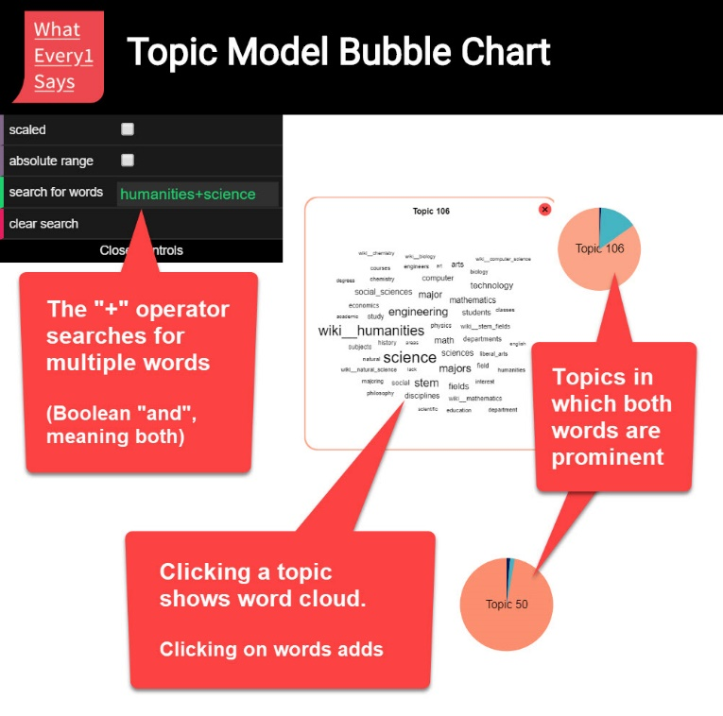

The two keywords you wish to compare: (single word only for each) | Enter keyword 1. | Enter keyword 1.

Steps 2 and 3 (repeated uses of Module 3.c for each keyword)
You will be asked to go through two separate repetitions of a truncated version of Module 3.c ("Analyze a keyword")--one for each of your words. When you have completed these, you will compare your observations on the words.

End of Block: IDENTIFY TWO WORDS TO COMPARE

Start of Block: START WORD 1 ANALYSIS

Start analysis of Keyword1:
Find topics in which your word is prominent.
Find the highest weight topics in which the keyword you are interested in is important (but omit any "super-topics" as defined in Module 2; reminder below). This can be done in several different ways using the general-purpose visualization interfaces in the WE1S Topic Model Observatory as instructed below. (For additional instructions on these tools, see the TMO Guide).
● Dfr-browser: Under the “Word Index” tab in Dfr-browser, click on the word you are studying to see a visualization of "prominent topics for [word]". See which topics the word is prominent in, where "prominent" means that the word shows up among the most frequent words in that topic.

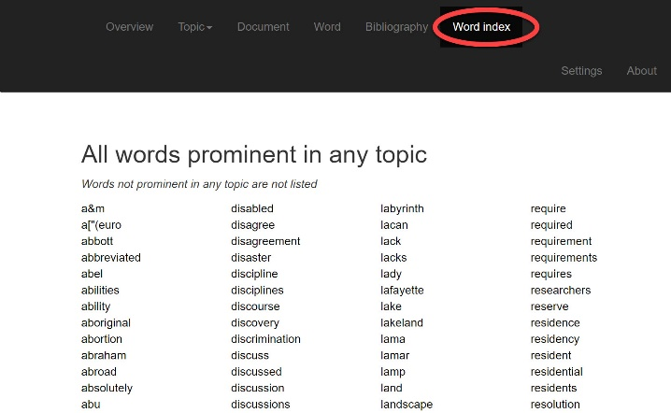 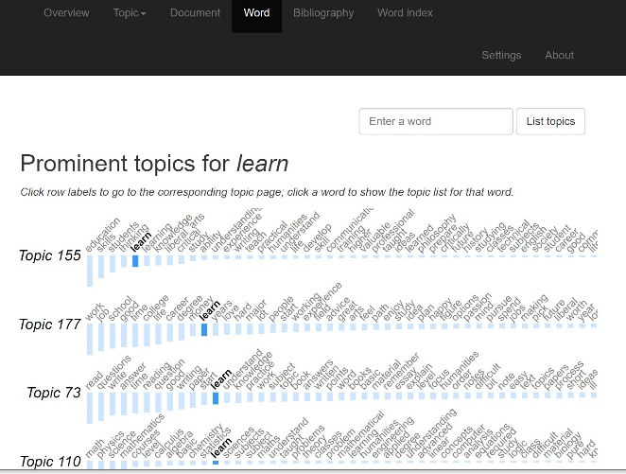
Screenshot 1:Dfr-browser "word index" view Screenshot 2: "prominent topics for [a word]" view
● TopicBubbles: Search for a word in TopicBubbles and see which larger topics the word shows up in and the relative importance of the word in that topic.

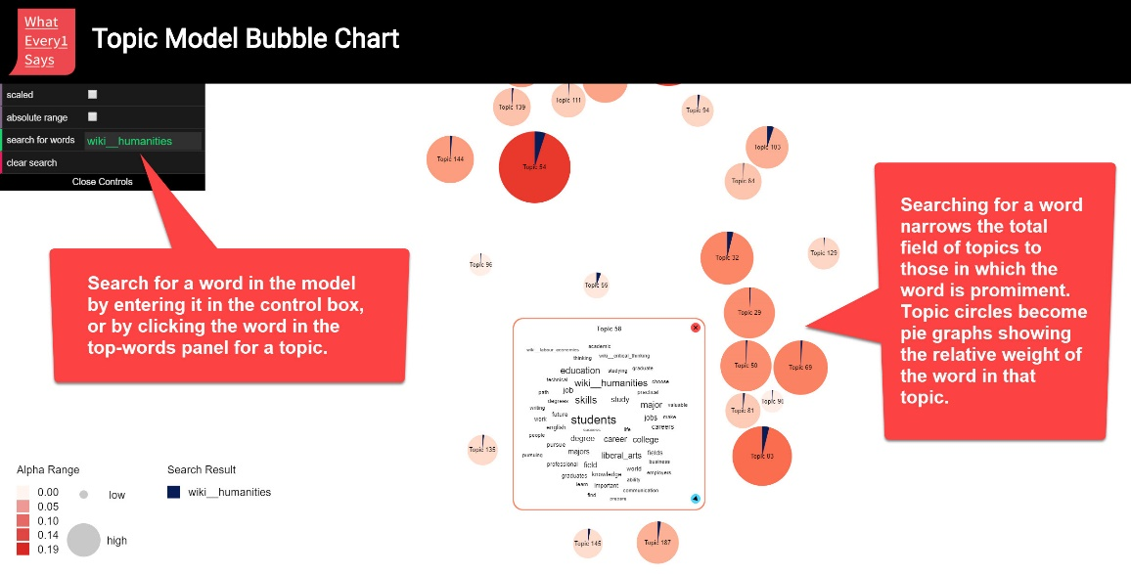
Screenshot: TopicBubbles - search for a word function
● pyLDAvis: In pyLDAvis, find a topic in which the word you are interested appears in the right-hand panel for "top-30 most salient terms." Then click on the word to see in the left-hand panel what large topics the word show up in. (You can also adjust the λ "lambda" metric for relevance of terms to a topic to fine-tune your sense of the relation of a word to a topic. The creators of this tool found in one test with a topic model that λ = 0.6 gave optimal results. See Sievert and Shirley.)
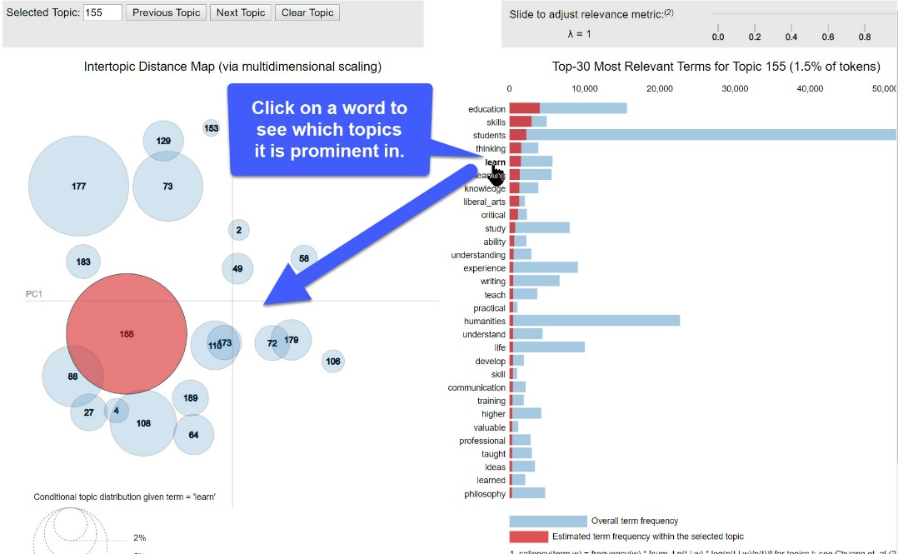
Screenshot 1: pyLDAvis - click on a word to see which topics it is prominent in.

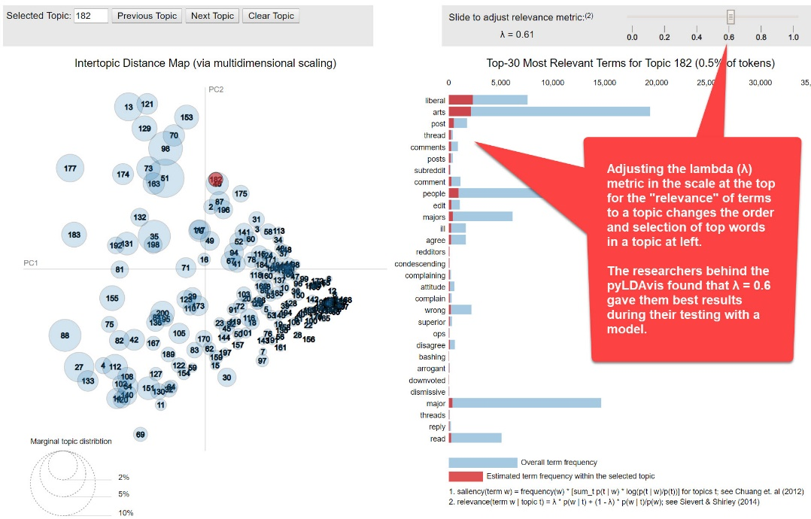
Screenshot 2: pyLDAvis - adjust λ (lambda) relevance metric

Identify some topics of interest in which the word you are studying is prominent: Below, identify by their topic numbers up to 10 topics of interest bearing on your research question that your word is prominent in. Also label the topics if you can (a label should be a word or short phrase representing only the objective part of your observation, or what the topic is “about”. It should not be formed as a sentence, which tends to posit a thesis.)
(If you have more than 10 topics of interest, then record them in notes in your "observation" commentary later in this exercise.)

Topics of interest in which the word you are studying is prominent.

Topic # | Label

End of Block: FIND TOPICS IN WHICH YOUR WORD IS PROMINENT

Start of Block: EXAMINE THE TOPICS YOU IDENTIFIED

Keyword 1: Examine the topics associated with your word that you have identified
Use the general-purpose interfaces in the Topic Model Observatory (Dfr-browser, TopicBubbles, and pyLDAvis) to examine the topics associated with your work that you have identified. For example,
- Look at other top words in those topics. (Remember that in pyLDAvis you can adjust the λ lambda metric for relevance of top words to a topic.)
- Look quickly at some of the documents most associated with those topics, and read a few of the documents.

You can also use the special purpose interfaces in the Topic Model Observatory to see other aspects of the topics. For example,
- See how topics are associated with particular publication sources or whole sets of such sources.
- See how two topics compare to each other in their relation to publication sources.
- See whether the topics are part of topic-clusters.

As you learn about your word in the context of the topics you have identified, start the running note below by making any observations that bear on your research question or are otherwise of interest.

Start a running note for Keyword 1:

Notes on topics in which your keyword 1 is prominent (enter below in the field).
[RunningNote1]

End of Block: EXAMINE THE TOPICS YOU IDENTIFIED

Start of Block: EXAMINE RELATED TOPICS

Keyword 1: Find and examine topics "related" through their top words to the topics you examined above
(1) First, if any of the topics you previously examined are in clusters with other topics, examine some of those other topics.
(2) Second, examine some topics whose top words are similar to those of one or more of the topics you earlier examined. "Similar" means:

- Suppose that in a topic you earlier examined the top five words are "cat, dog, horse, cow, chicken."
- Then find topics whose top five words include one or two of "cat, dog, horse, cow, chicken."
Identify below up to 5 such related topics and try to label them:

Related Topics

Topic # | Label

Now examine the related topics you identified above and add anything of interest to your running note for Keyword 1:

Add to or revise your running note for Keyword 1.
[RunningNote1]

End of Block: EXAMINE RELATED TOPICS

Start of Block: ARE THERE RELATED WORDS?

Keyword 1: Identify related words.
Having looked at your word, did you notice any related words in the topic model of the following kinds?
- words that are conceptually related to the keyword you just examined (e.g., terms that you might want to examine to continue investigating your research question)
- words morphologically related to the keyword you just examined (e.g., "sciences" if your just-examined word was "science") that might be looked at more closely to determine if they should or should not be consolidated in the topic model to be the same word ("token")

As due diligence, you may also want to use the Historical Thesaurus of the Oxford English Dictionary (HTOED) to look around the taxonomic neighborhood of your word for any obvious related words in the English language that you haven't noticed so far. Looking for such words in your topic model will often lead to the same topics you have already considered, but it may also lead down new avenues of exploration. (The HTOED provides a systematic taxonomic and chronological view of words categorized by related meanings. It is accessed through a link on the main OED page available through your university library's institutional subscription.)
(a) 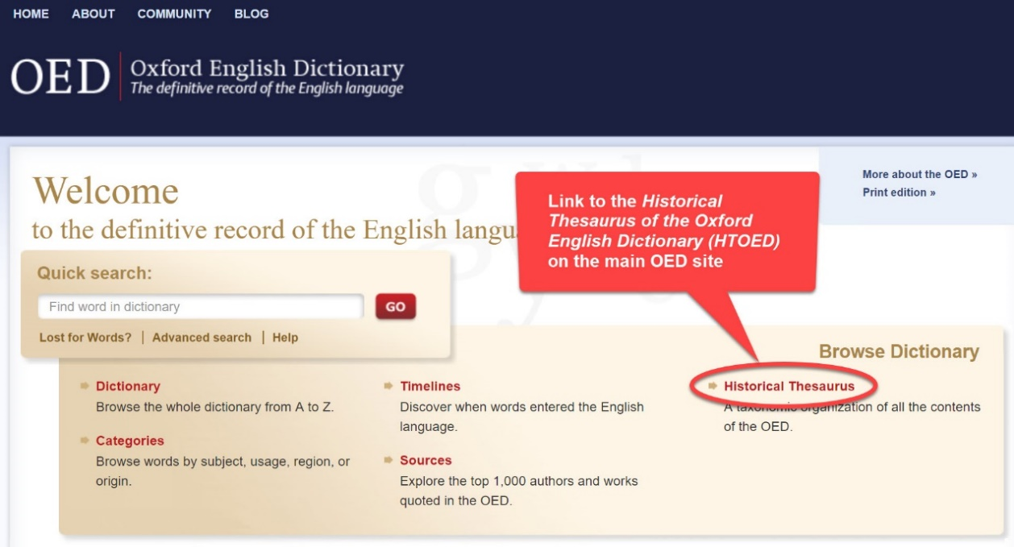
Screenshot A: Link to the HTOED on the OED site.
(b) 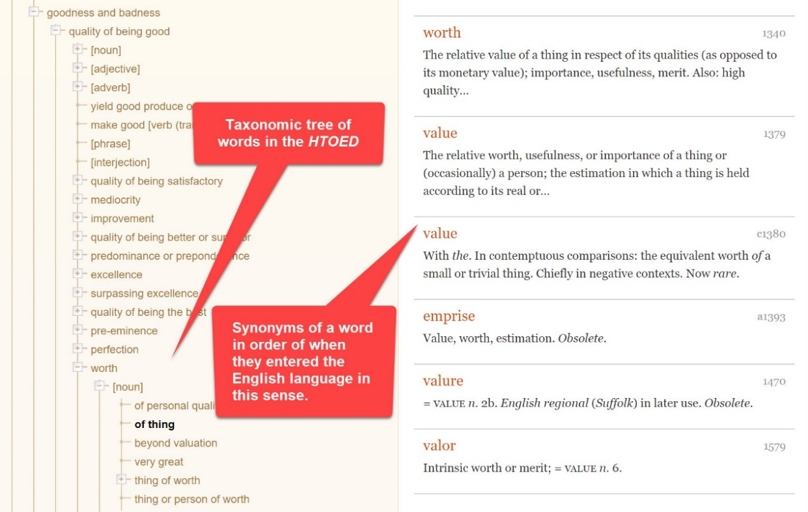
Screenshot B: example from the HTOED (taxonomic neighborhood of the word "value" and synonyms in the historical order they entered the language).
If you find related words of interest, please enter them below:

Conceptually related words (for Keyword 1):

Morphologically related words (for Keyword 1s:

End of Block: ARE THERE RELATED WORDS?

Start of Block: SUMMARY OBSERVATIONS

Keyword 1: Summary observation on your word
Please write a brief summary observation on the word you studied that bears on your research question (or explain why looking at the word does not allow you to advance on the question). Feel free to draw on, revise, or extend your running notes for this purpose.
An “observation” should have two parts: a more-or-less objective description in which you have high confidence; and a thesis, hypothesis, interpretation, or suggestion for which you have less confidence before you study the model more closely but that might bear on your research question.

For convenience, your previous note for Keyword 1 is repeated here (in live, editable form). Add yoru summary observation on your word below your previous notes.
[RunningNote1]

Add your summary observation for Keyword 1:

[RunningNote2]

End of Block: SUMMARY OBSERVATIONS

Start of Block: START WORD 2 ANALYSIS

Start analysis of Keyword 2:
Find topics in which your word is prominent.
Find the highest weight topics in which the keyword you are interested in is important (but omit any "super-topics" as defined in Module 2; reminder below). This can be done in several different ways using the general-purpose visualization interfaces in the WE1S Topic Model Observatory as instructed below. (For additional instructions on these tools, see the TMO Guide).
● Dfr-browser: Under the “Word Index” tab in Dfr-browser, click on the word you are studying to see a visualization of "prominent topics for [word]". See which topics the word is prominent in, where "prominent" means that the word shows up among the most frequent words in that topic.

Screenshot 1:Dfr-browser "word index" view Screenshot 2: "prominent topics for [a word]" view
● TopicBubbles: Search for a word in TopicBubbles and see which larger topics the word shows up in and the relative importance of the word in that topic.

Screenshot: TopicBubbles - search for a word function
● pyLDAvis: In pyLDAvis, find a topic in which the word you are interested appears in the right-hand panel for "top-30 most salient terms." Then click on the word to see in the left-hand panel what large topics the word show up in. (You can also adjust the λ "lambda" metric for relevance of terms to a topic to fine-tune your sense of the relation of a word to a topic. The creators of this tool found in one test with a topic model that λ = 0.6 gave optimal results. See Sievert and Shirley.)
Screenshot 1: pyLDAvis - click on a word to see which topics it is prominent in.

Screenshot 2: pyLDAvis - adjust λ (lambda) relevance metric

Identify some topics of interest in which the word you are studying is prominent: Below, identify by their topic numbers up to 10 topics of interest bearing on your research question that your word is prominent in. Also label the topics if you can (a label should be a word or short phrase representing only the objective part of your observation, or what the topic is “about”. It should not be formed as a sentence, which tends to posit a thesis.)
(If you have more than 10 topics of interest, then record them in notes in your "observation" commentary later in this exercise.)

Topics of interest in which the word you are studying is prominent.

Topic # | Label

End of Block: FIND TOPICS IN WHICH YOUR WORD IS PROMINENT

Start of Block: EXAMINE THE TOPICS YOU IDENTIFIED

Keyword 2: Examine the topics associated with your word that you have identified
Use the general-purpose interfaces in the Topic Model Observatory (Dfr-browser, TopicBubbles, and pyLDAvis) to examine the topics associated with your work that you have identified. For example,
- Look at other top words in those topics. (Remember that in pyLDAvis you can adjust the λ lambda metric for relevance of top words to a topic.)
- Look quickly at some of the documents most associated with those topics, and read a few of the documents.

You can also use the special purpose interfaces in the Topic Model Observatory to see other aspects of the topics. For example,
- See how topics are associated with particular publication sources or whole sets of such sources.
- See how two topics compare to each other in their relation to publication sources.
- See whether the topics are part of topic-clusters.

As you learn about your word in the context of the topics you have identified, start the running note below by making any observations that bear on your research question or are otherwise of interest.

Start a running note for Keyword 2:

Notes on topics in which your keyword 2 is prominent (enter below in the field).
[RunningNote3

End of Block: EXAMINE THE TOPICS YOU IDENTIFIED

Start of Block: EXAMINE RELATED TOPICS

Keyword 2: Find and examine topics "related" through their top words to the topics you examined above
(1) First, if any of the topics you previously examined are in clusters with other topics, examine some of those other topics.
(2) Second, examine some topics whose top words are similar to those of one or more of the topics you earlier examined. "Similar" means:

- Suppose that in a topic you earlier examined the top five words are "cat, dog, horse, cow, chicken."
- Then find topics whose top five words include one or two of "cat, dog, horse, cow, chicken."
Identify below up to 5 such related topics and try to label them:

Related Topics

Topic # | Label

Now examine the related topics you identified above and add anything of interest to your running note for Keyword 2:

Add to or revise your running note for Keyword 2.
[RunningNote3

End of Block: EXAMINE RELATED TOPICS

Start of Block: ARE THERE RELATED WORDS?

Keyword 2: Identify related words.
Having looked at your word, did you notice any related words in the topic model of the following kinds?
- words that are conceptually related to the keyword you just examined (e.g., terms that you might want to examine to continue investigating your research question)
- words morphologically related to the keyword you just examined (e.g., "sciences" if your just-examined word was "science") that might be looked at more closely to determine if they should or should not be consolidated in the topic model to be the same word ("token")

As due diligence, you may also want to use the Historical Thesaurus of the Oxford English Dictionary (HTOED) to look around the taxonomic neighborhood of your word for any obvious related words in the English language that you haven't noticed so far. Looking for such words in your topic model will often lead to the same topics you have already considered, but it may also lead down new avenues of exploration. (The HTOED provides a systematic taxonomic and chronological view of words categorized by related meanings. It is accessed through a link on the main OED page available through your university library's institutional subscription.)
(a)
Screenshot A: Link to the HTOED on the OED site.
(b)
Screenshot B: example from the HTOED (taxonomic neighborhood of the word "value" and synonyms in the historical order they entered the language).
If you find related words of interest, please enter them below:

Conceptually related words (for Keyword 1):

Morphologically related words (for Keyword 1s:

End of Block: ARE THERE RELATED WORDS?

Start of Block: SUMMARY OBSERVATIONS

Keyword 2: Summary observation on your word
Please write a brief summary observation on the word you studied that bears on your research question (or explain why looking at the word does not allow you to advance on the question). Feel free to draw on, revise, or extend your running notes for this purpose.
An “observation” should have two parts: a more-or-less objective description in which you have high confidence; and a thesis, hypothesis, interpretation, or suggestion for which you have less confidence before you study the model more closely but that might bear on your research question.

For convenience, your previous note for Keyword 2 is repeated here (in live, editable form). Add your summary observation on your word below your previous note.
[RunningNote3

Add your summary observation for Keyword 2:

[RunningNote4]

End of Block: SUMMARY OBSERVATIONS

Start of Block: COMPARE OBSERVATIONS ON WORDS 1 AND 2

Last analysis step (comparison).
Below are reminders of your examination of your words 1 and 2, followed by questions that ask you to compare, related, and synthesize.

Reminder: Your summary observations on Word 1:

[RunningNote2]

Reminder: Your summary observations on Word 1:

[RunningNote4]

COMPARE WORDS 1 & 2 Think about the relation between Word 1 and Word 2 and how that relation bears on your research question.
As noted earlier in this exercise, an excellent tool to use in relating two (or more) words in a topic model is TopicBubbles. You might want to augment your exploration of each word individually by looking at them together in TopicBubbles.
Reminder: TopicBubbles allows you to search for which topics two (or more) words are both promiment in. See the screenshot below for instructions (and the TMO Guide, chapter 2, section 4.c, for a more detailed explanation).
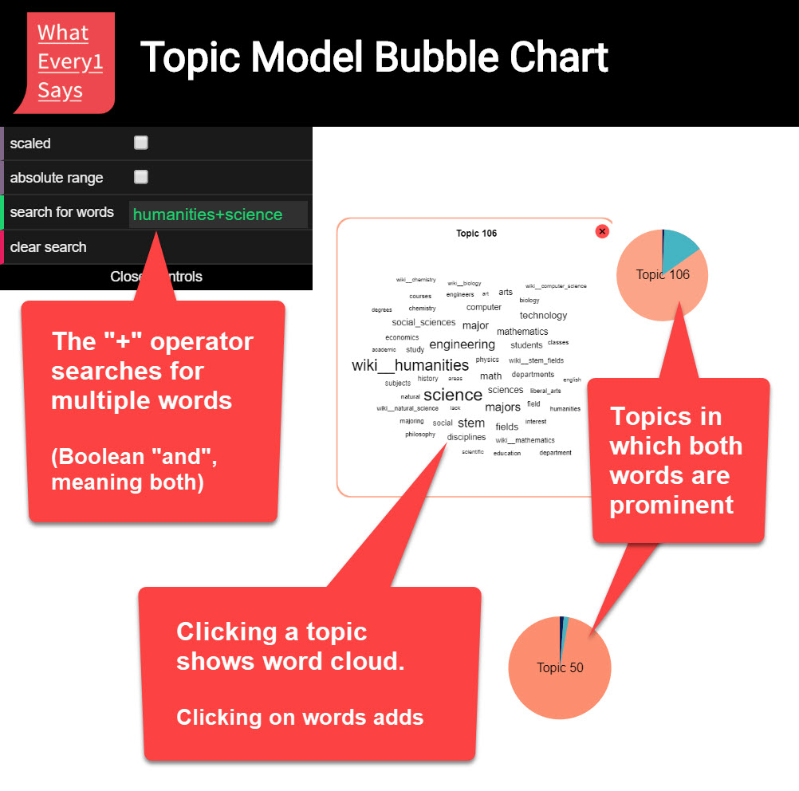

SUMMARY COMPARISON Compare or reflect on the relation between Word 1 and Word 2
Drawing on your previous notes and observations, write a brief summary observation in which you compare the two keywords you have examined in ways that might advance your research question.
An “observation” should have two parts: a more-or-less objective description in which you have high confidence; and a thesis, hypothesis, interpretation, or suggestion for which you have less confidence before you study the model more closely but that might bear on your research question.

[FinalNote]

End of Block: COMPARE OBSERVATIONS ON WORDS 1 AND 2

Start of Block: RESEARCH TAKEAWAYS (v. 2, created 23 June 2019; rev. 27 June 2019)

TAKEAWAYS: Before you finish: Research Takeaways?
After studying your topic model in this exercise, are there any research takeaways you want to record, store, describe, or log (depending on the nature of the takeaway) to provide key evidence, materials, and data that can be used in writing up a report on your research question or for future humanities advocacy? For example, a research takeaway can be:
- Evidence in the form of an important topic(s) or relation between topic(s) and words, documents that you want to describe so that you can find it again;
- A screenshot of something you found while analyzing your topic model with one of the Topic Model Observatory visualization interfaces;
- Citations for or excerpts from key documents associated with a topic (e.g., three newspaper articles you want to use in a report);
- A text copy of words in a topic ranked by proportional weight;
- Etc.
If you have found such research takeaways, record, store, or describe them as appropriate in your team folder on the WE1S Google team drive. You may also want quickly to log or make a note about your takeaways in the field below in order to have a record of them as associated with this survey. That way, when you read over your survey results, you can remember what you took away and where you stored or annotated it. P.S. Some of the Topic Model Observatory interfaces may also allow you to use the Hypothes.is web annotation tool to highlight or annotated them in your browser for private or shared use.

Companion questions?
"Companion questions" may be defined as questions that help provide context for the research question you are currently addressing or that are follow-on questions you might want to pursue later. WE1S asks you periodically to consider if companion questions have occurred to you because it's a good way to prevent the kind of "tunnel vision" that research can sometimes create.
This is best explained by way of example. Suppose that your research question concerns the degree and nature of discussion about the "humanities crisis." A tunnel-vision view of the problem would be to consider only discussion of the "humanities crisis." A contextually wider view would consider companion questions such as the following: what is the degree and nature of discussion about other kinds of crisis by comparison? For example, in what other contexts (political, economic, spiritual, etc.) does the word "crisis" tend to appear? Do mentions of "crisis" in all these contexts tend to spike up together, or be concentrated in certain kinds of media or sources? Etc.
Having advanced on your research question using the present module, have any "companion questions" occurred to you? If so, please set them down here so that they can be remembered for possible future use:

End of Block: RESEARCH TAKEAWAYS (v. 2, created 23 June 2019; rev. 27 June 2019)

Start of Block: SURVEY END (v.2, created 20 June 2019, rev. 28 June 2019)

CONFIDENCE?
Final consideration -- Confidence assessment
It is possible after conducting an interpretation exercise to conclude that you have either high or low confidence in the results (with confidence descending all the way down to a null result).
Please rank your level of confidence in the results of this interpretation exercise on the following scale:
1 ----------------------------------------------------- to ------------------------------------------------- 10
(1 = null result) (10 = full confidence)
Choose a confidence value.

Suggestions about this module?
Do you have any suggestions about this module of the WE1S Interpretation Protocol (problems, improvements)?

Important: Save this completed module in your team working folder.
Please save this completed module of the Interpretation Protocol in your team’s working folder:
[FolderURL]
This module is part of the documentary evidence trail for your future research reports and Key Finding cards.

END This is the end of the current module of the WE1S Interpretation Protocol.

End of Block: SURVEY END (v.2, created 20 June 2019, rev. 28 June 2019)

