(v. 2) Module 3.a - Analyze a topic

Start of Block: INFO ABOUT YOU & EXERCISE

IS THIS A TRIAL?
Before you begin, please check the choice below if this is just a trial or experimental exercise that should be ignored in collecting outputs from this module.
☐ Check this field if this is just a trial.

OPEN RESEARCH POLICY STATEMENT
The modules of the WE1S Interpretation Protocol create records of research that support the project's aim of advancing "open, generalizable, and replicable digital humanities methodology" (see project "About" statement). This aim is related to current practices of "open science" and "open-notebook science." The basic idea is that the materials, methods, steps, and findings of research should be transparent so that other researchers know how conclusions were reached and can test or reproduce the process--an ideal that is especially needed for understanding such machine-learning methods as topic modeling (see WE1S bibliography on machine-learning interpretability).
In completing this and other modules of the WE1S Interpretation Protocol you are creating an "open notebook" that in principle can be shared with others as a public record of research. Please be sure that all descriptions, observations, and notes you write in this module are consistent with being part of public record--that is, appropriate in tone, respectful to others, and not in violation of privacy or copyright restrictions.
However please also do not let the ideal of open-notebook science inhibit you from speculative or tentative in-progress commentary. It is understood that research, open or otherwise, is a process of finding knowledge with many stages and levels of confidence. (At the conclusion of this and other modules of the Interpretation Protocol, you will be asked to rate your confidence level in the current exercise.)
In addition, lab notebooks are allowed to be messy as a part of the research process. It is not expected that notes written into these modules be copyedited as if for formal publication. (The time for polishing is later when writing up a report synthesizing results from one or more modules of this Interpretation Protocol.)

EXERCISE INFO
Please enter the following the following information, which will generate an "Exercise ID". (Tab from input field to input field to force calculation of the Exercise ID.)
- Your name or team name. (If team, then use the format "Team1", "Team2", etc. Please do not use a space): [Name]
- Interpretation project number (e.g., "4," indicating that this is the fourth interpretation project for you or your team that the exercise with this module is part of): [Project#]
- Which stage of your present interpretation project does this module represent? (E.g., if this module is the second you have used in the sequence of modules for the same interpretation project, then write the number "2" here. If multiple team members are working in parallel using various modules, then follow the convention of adding name-abbreviation—e.g., 2AL: [Stage#]
- The present Interpretation Protocol module you are using is set as follows: 3a
(This is part of your auto-generated exercise ID below, and cannot be altered in the present module document.)
- Today's date in the format YYYY-MM-DD (e.g., 2020-07-06) (use the date-picker calendar): [Date]

Your team folder in the project Google team working space.
This refers to your team working folder for notes, reports, materials, etc. related to interpretation work in the WE1S Google Team drive’s _Team Working Space folder. Go there to find the folder your team created for your work.
[FolderURL]

Exercise ID
The ID for the present exercise (generated from the information you just provided) is as follows. (If you see a mistake, please go "back" in this survey and correct the information that generated the Exercise ID.)
[Name]_ [Project#]_ [Stage#]_3a_ [Date]

Exercise Description
To assist in remembering what the exercise using this module is about, please enter below a very brief description of what you are currently doing (e.g., "We are now going to compare the keywords 'humanities' and 'sciences' in the 20190621_2132_us-humanities-top-newspapers---topics200 model.")
Click or tap here to enter text.

Topic model you are studying
For the topic model you are studying, please enter below its "topic model name" and "start page" URL. A "topic model name" looks like this: "20190621_2132_us-humanities-top-newspapers---topics200". You can locate this name in the Registry of WE1S Topic Models. Note that this is the name of the specific granularity of the model you are studying (number of topics). The "start page" is the URL of the overall topic model (including all its granularities and their visualizations) listed on this page on the Harbor 10002 server: Index of / projects/. (You can also find this URL in the Registry of WE1S Topic Models.) A start page URL looks like this: http://harbor.english.ucsb.edu:10002/projects/20190621_2132_us-humanities-top-newspapers/
Topic model name: Click or tap here to enter text.
"Start page" URL: Click or tap here to enter text.

Research question you are addressing
Please enter below information about the research question you are addressing in this exercise. You can find this information in the "Registry of WE1S Research Questions." (If you are taking an overview of a model prior to working on a specific research question, just enter "Taking an overview")
Research question:
Click or tap here to enter text.
Operationalized form of question:
Click or tap here to enter text.
Research question ID (use the format "team2-q1", representing in this example team 2's first research question): Click or tap here to enter text.

Previous Interpretation Protocol modules you used to address your research question (if any) [optional]
Enter in sequence below any Interpretation Protocol modules you have already completed in previous steps of your current interpretation project. For example, if for steps 1-3 preceding this exercise (where the current exercise is now step 4 in the sequence) you previously used modules 3a, 3b, and 3c in that order, then enter those module numbers in that sequence.
Previous module sequence: Click or tap here to enter text.

End of Block: INFO ABOUT YOU & EXERCISE (v. 2, created 9 June 2019, rev. 7 July 2019)

Start of Block: WHAT THIS MODULE DOES

What module 3a does
(Module 3.a, v. 2, created 20 June 2019; last rev. 23 June 2019.)
The purpose of this module 3.a of the WE1S topic model Interpretation Protocol is to examine a specific topic.
End of Block: WHAT THIS MODULE DOES

Start of Block: IDENTIFY TOPIC TO EXAMINE
Step 1. Identify a topic to examine
Modules 1 (Overview) and 2 (Representative topics) in the WE1S Interpretation Protocol will previously have given you an overall sense of topics in the model you are looking at. Based on that initial understanding of the model, and using a combination of the tools in the WE1S Topic Model Observatory (see TMO Guide), look over the topics in the model and identify a particular topic that you want to examine closely to address your research question.
Enter the number of that topic below:
Number of the topic you are studying.

TOPIC WEIGHT LEVEL
Using the general-purpose tools in the Topic Model Observatory (Dfr-Browser, TopicBubbles, pyLDAvis), examine the proportional weight of the topic relative to other topics in the model. Would you rank this as a high-weight, middle-weight, or low-weight topic?
(Remember that you learned about "terraces" of high/middle/low weight topics in Module 2.)
The topic I identified is:
☐ high weight

☐ middle weight

☐ low weight

End of Block: IDENTIFY TOPIC TO EXAMINE

Start of Block: EXAMINE TOPIC

Step 2. Examine your topic and take some notes
(a) Using the general-purpose interface in the Topic Model Observatory (Dfr-Browser, Topic Bubbles, and pyLDAvis), examine the top words in your topic. (Remember that in pyLDAvis you can adjust the λ "lambda" metric for relevance of terms to a topic to fine-tune your sense of the relation of top words to a topic. The creators of this tool found in one test with a topic model that λ = 0.6 gave optimal results. See Sievert and Shirley.)
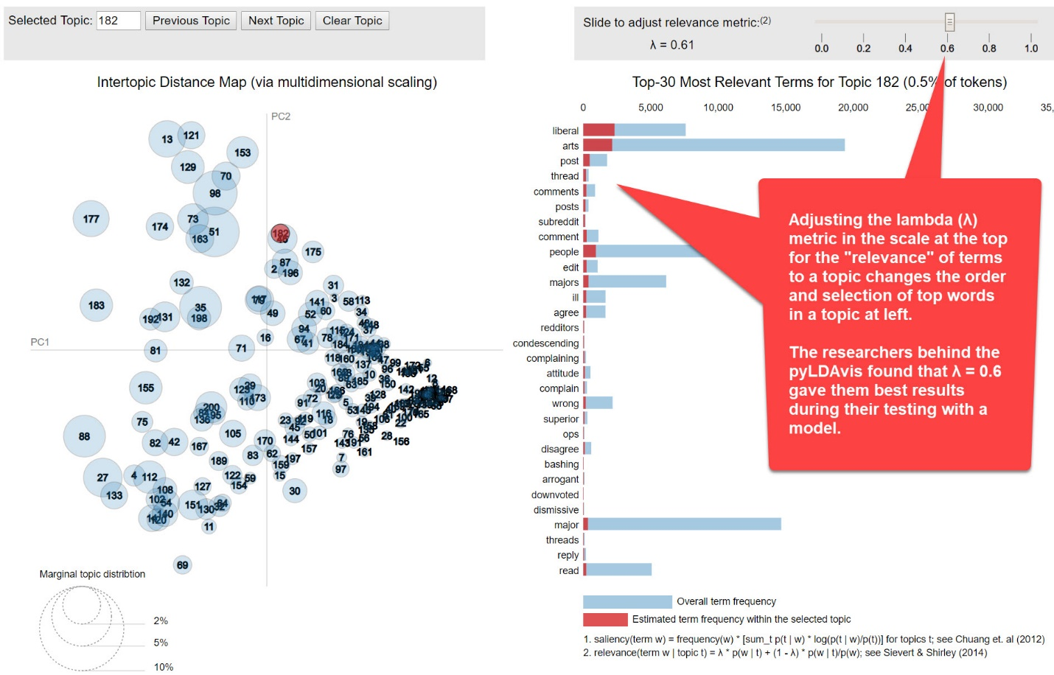
Screenshot: pyLDAvis - adjust λ (lambda) relevance metric
Evaluate the coherence of the top words as a group and consider what you might label this topic based on the words. (A topic label should be a short descriptive phrase consisting usually of no more than two concepts related to each other--e.g., "college majors and careers." A label should not be in the form of a thesis argument--e.g., not something like "college majors make little difference in careers")
(b) Using the special-purpose interfaces of Metadata-pyLDAvis and Metadata7D in the Topic Model Observatory (see TMO Guide, chapters 4 and 5), examine the relation of your topic to publication sources (to see, for example, if the topic is heavily associated with some particular source or set/kind/region of sources.
(c) Using the special-purpose interfaces of Clusters7D and DendrogramViewer in the Topic Model Observatory (see TMO Guide, chapters 7 and 8), see if your topic is part of a cluster of topics or an outlier. If it is part of what seems to be a cluster of topics, take a quick look at some of the neighboring topics.
(d) Using the Dfr-Browser topic view, take a look at the top documents associated with this topic. (You can also use Metadata-pyLDAvis to see the top documents assocated with your topic.)

Your Notes: Take some running notes below in regard to whatever you find that is of interest in regard to instructions #a, b, c, d above. Later in this module you can draw on these notes to make a summary observation.
An “observation” should have two parts: a more-or-less objective description in which you have high confidence; and a thesis, hypothesis, interpretation, or suggestion for which you have less confidence before you study the model more closely but that might suggest avenues of research.
[RunningNote1]

Label your topic:
Try to label your topic. (A label should be a word or short phrase representing only the objective part of your observation, or what the topic is “about”. It should not be formed as a sentence, which tends to posit a thesis.)
Label your topic here.

OBSERVE TOPIC
Please write a summary observation on this topic: Drawing on, revising, and extending your running notes, write a summary observation on your topic designed to address your research question.
For the purpose of addressing a research question, a good “observation” should have two parts: a more-or-less objective description in which you have high confidence; and a thesis, hypothesis, interpretation, or suggestion bearing on your research question.

To assist you in making a final, summary observation, here are your notes so far from earlier sections of this module. (These are editable; editing will also change your previous entries in this document.)
Your Previous Note:
[RunningNote1]
- - - - - - - - - - - - - - - - - - - - - - - - - - - - - - - - - - - - - - - - - - - - - - - - - - - - - - - - - - - - - - - - - - - - - - - - - - - - - - - -
Enter below your final, summary observations:
[FinalNote]

End of Block: EXAMINE TOPIC

Start of Block: RESEARCH TAKEAWAYS (v. 2, created 23 June 2019; rev. 27 June 2019)

TAKEAWAYS: Before you finish: Research Takeaways?
After studying your topic model in this exercise, are there any research takeaways you want to record, store, describe, or log (depending on the nature of the takeaway) to provide key evidence, materials, and data that can be used in writing up a report on your research question or for future humanities advocacy? For example, a research takeaway can be:
- Evidence in the form of an important topic(s) or relation between topic(s) and words, documents that you want to describe so that you can find it again;
- A screenshot of something you found while analyzing your topic model with one of the Topic Model Observatory visualization interfaces;
- Citations for or excerpts from key documents associated with a topic (e.g., three newspaper articles you want to use in a report);
- A text copy of words in a topic ranked by proportional weight;
- Etc.
If you have found such research takeaways, record, store, or describe them as appropriate in your team folder on the WE1S Google team drive. You may also want quickly to log or make a note about your takeaways in the field below in order to have a record of them as associated with this survey. That way, when you read over your survey results, you can remember what you took away and where you stored or annotated it. P.S. Some of the Topic Model Observatory interfaces may also allow you to use the Hypothes.is web annotation tool to highlight or annotated them in your browser for private or shared use.

Companion questions?
"Companion questions" may be defined as questions that help provide context for the research question you are currently addressing or that are follow-on questions you might want to pursue later. WE1S asks you periodically to consider if companion questions have occurred to you because it's a good way to prevent the kind of "tunnel vision" that research can sometimes create.
This is best explained by way of example. Suppose that your research question concerns the degree and nature of discussion about the "humanities crisis." A tunnel-vision view of the problem would be to consider only discussion of the "humanities crisis." A contextually wider view would consider companion questions such as the following: what is the degree and nature of discussion about other kinds of crisis by comparison? For example, in what other contexts (political, economic, spiritual, etc.) does the word "crisis" tend to appear? Do mentions of "crisis" in all these contexts tend to spike up together, or be concentrated in certain kinds of media or sources? Etc.
Having advanced on your research question using the present module, have any "companion questions" occurred to you? If so, please set them down here so that they can be remembered for possible future use:

End of Block: RESEARCH TAKEAWAYS (v. 2, created 23 June 2019; rev. 27 June 2019)

Start of Block: SURVEY END (v.2, created 20 June 2019, rev. 28 June 2019)

CONFIDENCE?
Final consideration -- Confidence assessment
It is possible after conducting an interpretation exercise to conclude that you have either high or low confidence in the results (with confidence descending all the way down to a null result).
Please rank your level of confidence in the results of this interpretation exercise on the following scale:
1 ----------------------------------------------------- to ------------------------------------------------- 10
(1 = null result) (10 = full confidence)
Choose a confidence value.

Suggestions about this module?
Do you have any suggestions about this module of the WE1S Interpretation Protocol (problems, improvements)?

Important: Save this completed module in your team working folder.
Please save this completed module of the Interpretation Protocol in your team’s working folder:
[FolderURL]
This module is part of the documentary evidence trail for your future research reports and Key Finding cards.

END This is the end of the current module of the WE1S Interpretation Protocol.

End of Block: SURVEY END (v.2, created 20 June 2019, rev. 28 June 2019)

